目 录
1 OpenEuler RISC-V 测试 - 1 -
1.1 操作系统（Ubuntu20.04） - 1 -
1.2 下载qemu，并编译安装 - 2 -
1.3 下载OpenEuler RISC- V镜像 - 14 -
1.4 安装运行测试neofetch - 16 -

OpenEuler RISC-V 测试

操作系统（Ubuntu20.04）
在终端输入，查看当前操作系统版本。
Linux version 5.8.0-43-generic (buildd@lcy01-amd64-018) (gcc (Ubuntu 9.3.0-17ubuntu1~20.04) 9.3.0, GNU ld (GNU Binutils for Ubuntu) 2.34) #49~20.04.1-Ubuntu SMP Fri Feb 5 09:57:56 UTC 2021
设置国内镜像源。在终端输入 ，在打开的编辑器中删去原内容将以下内容粘贴进去，然后保存、退出。
deb http://mirrors.aliyun.com/ubuntu/ focal main restricted universe multiverse
deb-src http://mirrors.aliyun.com/ubuntu/ focal main restricted universe multiverse

deb http://mirrors.aliyun.com/ubuntu/ focal-security main restricted universe multiverse
deb-src http://mirrors.aliyun.com/ubuntu/ focal-security main restricted universe multiverse

deb http://mirrors.aliyun.com/ubuntu/ focal-updates main restricted universe multiverse
deb-src http://mirrors.aliyun.com/ubuntu/ focal-updates main restricted universe multiverse

deb http://mirrors.aliyun.com/ubuntu/ focal-proposed main restricted universe multiverse
deb-src http://mirrors.aliyun.com/ubuntu/ focal-proposed main restricted universe multiverse

deb http://mirrors.aliyun.com/ubuntu/ focal-backports main restricted universe multiverse
deb-src http://mirrors.aliyun.com/ubuntu/ focal-backports main restricted universe multiverse
在终端执行以下命令：
sudo apt update
sudo apt upgrade

下载qemu，并编译安装
在终端输入以下命令：
mkdir ~/openEuler/
mkdir ~/openEuler/RISC-V
cd ~/openEuler/RISC-V
wget https://download.qemu.org/qemu-7.0.0.tar.xz
tar xnJf qemu-7.0.0.tar.xz
cd qemu-7.0.0
sudo apt-get install build-essential zlib1g-dev pkg-config libglib2.0-dev binutils-dev libboost-all-dev autoconf libtool libssl-dev libpixman-1-dev python-dev python3-pip python-capstone virtualenvninja-build
./configure --target-list=riscv64-softmmu,riscv64-linux-user --prefix=/home/civy/openEuler/RISC-V/program/riscv64-qemu
终端输出以下信息：

继续在终端输入以下命令：
make
make install
设置环境变量：
gedit ~/.bashrc
在打开的文档末尾加入以下内容：
export QEMU_HOME=/home/civy/openEuler/RISC-V/program/riscv64-qemu
export PATH=$QEMU_HOME/bin:$PATH
保存退出，新建一个终端，echo $PATH，查看环境变量：
环境变量设置成功。
验证安装是否正确：
qemu-system-riscv64 --version

下载OpenEuler RISC- V镜像
cd ~/openEuler/RISC-V
wget https://repo.openeuler.org/openEuler-preview/RISC-V/Image/fw_payload_oe.elf --no-check-certificate
Wget https://repo.openeuler.org/openEuler-preview/RISC-V/Image/openEuler-preview.riscv64.qcow2
git clone https://gitee.com/yunxiangluo/riscv-openeuler.git
vim run.sh

gedit run.sh,在打开的文件中输入以下内容：
qemu-system-riscv64 \
-nographic -machine virt \
-smp 8 -m 4G \
-kernel fw_payload_oe.elf \
-drive file=openEuler-preview.riscv64.qcow2,format=qcow2,id=hd0 \
-object rng-random,filename=/dev/urandom,id=rng0 \
-device virtio-rng-device,rng=rng0 \
-device virtio-blk-device,drive=hd0 \
-device virtio-net-device,netdev=usernet \
-netdev user,id=usernet,hostfwd=tcp::12055-:22 \
-append 'root=/dev/vda1 rw console=ttyS0 systemd.default_timeout_start_sec=600 selinux=0 highres=off mem=4096M earlycon' \
-bios none
保存退出。
chmod +x run.sh
./run.sh
提示无法分配内存。再次打开run.sh，根据Ubuntu系统CPU数量和内存容量，修改参数重新执行：
qemu-system-riscv64 \
-nographic -machine virt \
-smp 1 -m 2G \
-kernel fw_payload_oe.elf \
-drive file=openEuler-preview.riscv64.qcow2,format=qcow2,id=hd0 \
-object rng-random,filename=/dev/urandom,id=rng0 \
-device virtio-rng-device,rng=rng0 \
-device virtio-blk-device,drive=hd0 \
-device virtio-net-device,netdev=usernet \
-netdev user,id=usernet,hostfwd=tcp::12055-:22 \
-append 'root=/dev/vda1 rw console=ttyS0 systemd.default_timeout_start_sec=600 selinux=0 highres=off mem=2048M earlycon' \
-bios none
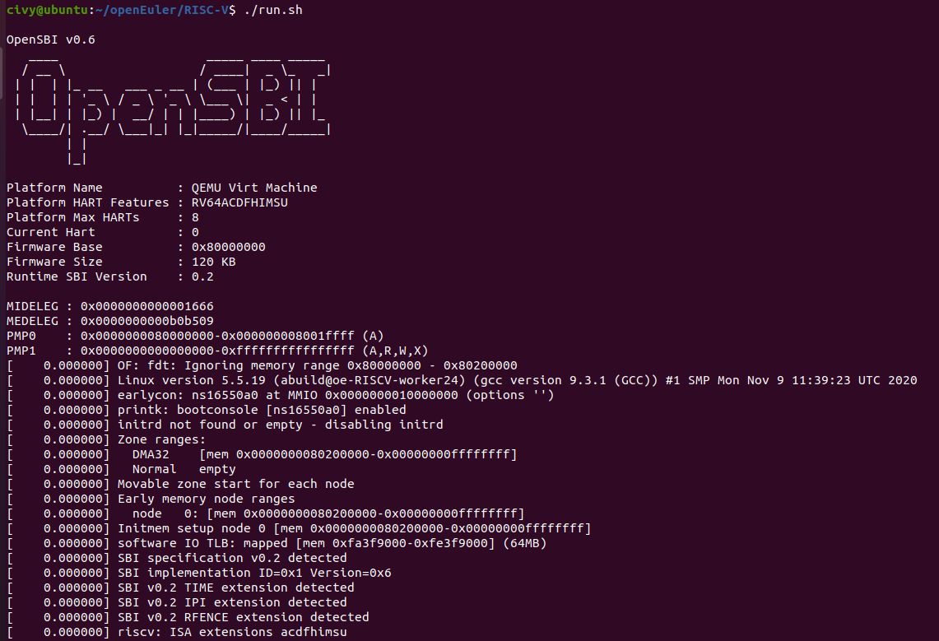
登录用户名：root 默认密码：openEuler12#$
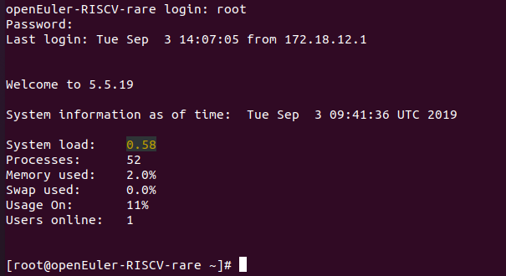

安装运行测试neofetch
原openEuler登录终端不要关闭，新建一个终端，执行以下命令：
git clone https://github.com/dylanaraps/neofetch
scp -P 12055 -r neofetch/ root@127.0.0.1:./
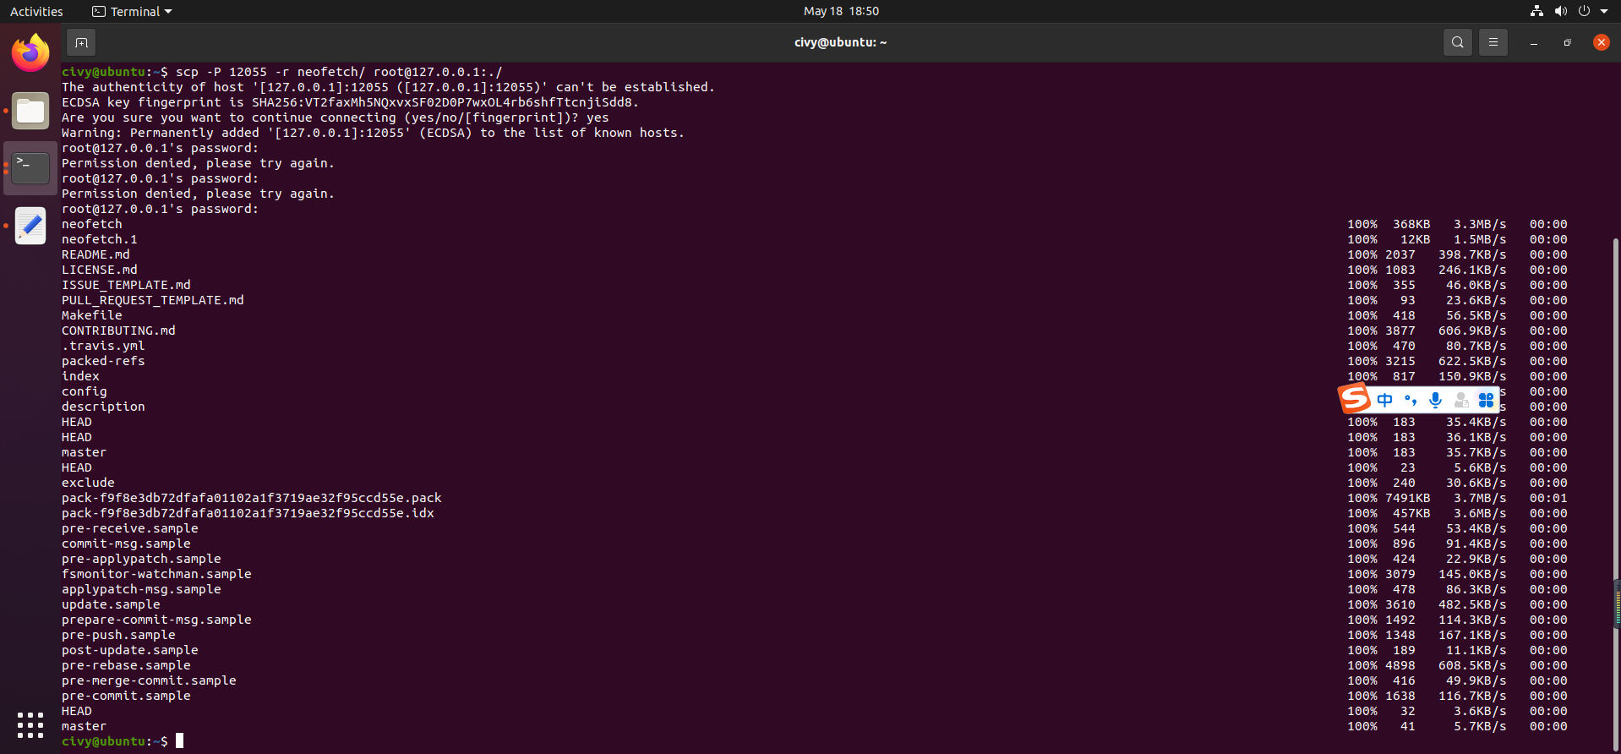
在原openEuler登录终端中执行以下命令：
cd neofetch/
sudo make install
Neofetch
